BIT 4107 – MOBILE APPLICATION DEVELOPMENT

DOCUMENATION

STUDENT NAME: SHALOM KIBOKO
ADMISSION NUMBER: BIT/2025/39237
SCHOOL/FACULTY: COMPUTING AND INFROMATICS
PROGRAMME: BACHELOR OF SCIENCE IN INFORMATION TECHNOLOGY
ACADEMIC YEAR: 2
SEMESTER: 2
LECTURER: MR.NYORO MICHAEL
PHONE NUMBER: 0725865117
PROJECT TITLE: REAL_APP – STUDENT/USER API MOBILE APPLICATION

DECLARATION
I hereby declare that this project documentation is my original work developed as part of the BIT4107 Mobile Application Development course. The work presented has not been submitted elsewhere for academic assessment. All sources of information used have been acknowledged appropriately.

ACKNOWLEDGEMENT
I would like to thank Mr. Nyoro Michael for his guidance and support throughout the Mobile Application Development course. I also appreciate the resources provided during practical sessions and the knowledge gained in Flutter mobile application development.
Contents
DECLARATION i
ACKNOWLEDGEMENT ii
CHAPTER ONE: INTRODUCTION 1
1.1 INTRODUCTION 1
1.2 PROBLEM STATEMENT 1
CHAPTER 2: SYSTEM ANALYSIS AND DESIGN 3
CHAPTER THREE: SYSTEM IMPLEMENTATION 4
CHAPTER FOUR : CHALLENGES ENCOUNTERED 5
CHAPTER FIVE: CONCLUSION 5
REFERENCES 6
APPENDIX 7

CHAPTER ONE: INTRODUCTION

1.1 INTRODUCTION

This report presents a structured practical approach to mobile application development using modern industry tools and frameworks. The project focuses on designing, developing, testing, and preparing a cross-platform mobile application using Flutter and related technologies. The development process follows a weekly breakdown from Week 1 to Week 5, covering setup, programming, UI design, implementation, and testing.

1.2 PROBLEM STATEMENT

Many beginner developers lack exposure to real-world mobile development workflows such as environment setup, API integration, UI/UX design, version control, and deployment. This creates a gap between academic learning and industry expectations.

1.3 OBJECTIVES
Main Objective
To develop a functional and industry-standard mobile application using modern development tools.
Specific Objectives
- To set up mobile development environments
- To learn programming languages used in mobile development
- To design and implement user interfaces
- To develop and test mobile applications using Flutter
- To integrate APIs and backend services
- To deploy projects using GitHub

1.4 SCOPE OF THE PROJECT

The project covers mobile application development using Flutter framework, Dart programming language, Android Studio, VS Code, Figma, GitHub, and Firebase/REST APIs.

1.5 TOOLS AND TECHNOLOGIES USED
- Android Studio – Primary IDE for Flutter development
- Visual Studio Code (VS Code) – Code editor
- Dart – Flutter development
- Flutter – Cross-platform mobile framework
- Firebase – Backend services
- REST APIs – Data communication
- SQLite – Local storage
- Figma – Wireframing and UI design
- GitHub – Project hosting and submission platform

CHAPTER 2: SYSTEM ANALYSIS AND DESIGN
System Architecture
The application follows a Client-Server Architecture.
Client
Flutter Mobile Application
Server
JSONPlaceholder REST API
Communication
HTTP GET Requests
Data Format
JSON
System Flow
- User opens application.
- Application sends HTTP request.
- API returns JSON data.
- Application processes JSON data.
- Data is displayed in a list format.

CHAPTER THREE: SYSTEM IMPLEMENTATION
User Interface Implementation
The user interface was developed using Flutter widgets and layouts designed through Figma prototypes.
Implemented screens include:
- Login Screen
- Home Screen
- Dashboard Screen
- Profile Screen
- Settings Screen
- Navigation flow

CHAPTER FOUR : CHALLENGES ENCOUNTERED
Challenge
Flutter setup issues
UI implementation difficulties
API integration challenges
Debugging errors

CHAPTER FIVE: CONCLUSION
The project successfully achieved its objectives by developing a Flutter-based mobile application capable of displaying data from an external REST API. Through this project, practical skills in Flutter development, UI design, API integration, testing, and debugging were acquired.
The project demonstrates the importance of modern mobile application development techniques and provides a foundation for future advanced mobile applications.

REFERENCES
Google Developers. (2026). Flutter Documentation. Available at: https://flutter.dev
Android Developers. (2026). Android Studio Official Documentation. Available at: https://developer.android.com/studio
JSONPlaceholder. (2026). Free Fake REST API for Testing. Available at: https://jsonplaceholder.typicode.com
GitHub Inc. (2026). GitHub Documentation and Version Control Guide. Available at: https://github.com
Figma. (2026). UI/UX Design Tool Documentation. Available at: https://www.figma.com
Firebase Documentation. (2026). Google Firebase Platform. Available at: https://firebase.google.com

APPENDIX
Appendix A: Screenshots
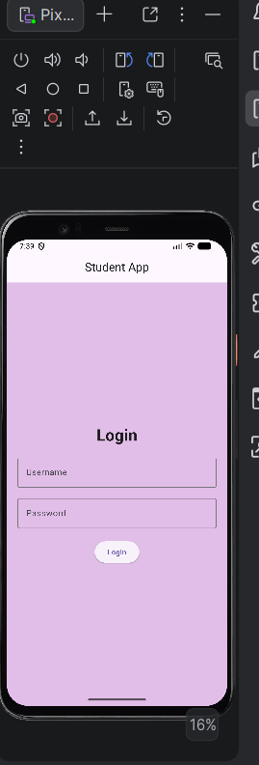
- Login Screen

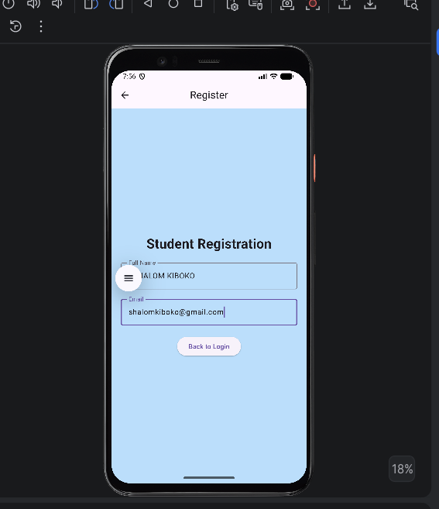
- Registration Screen

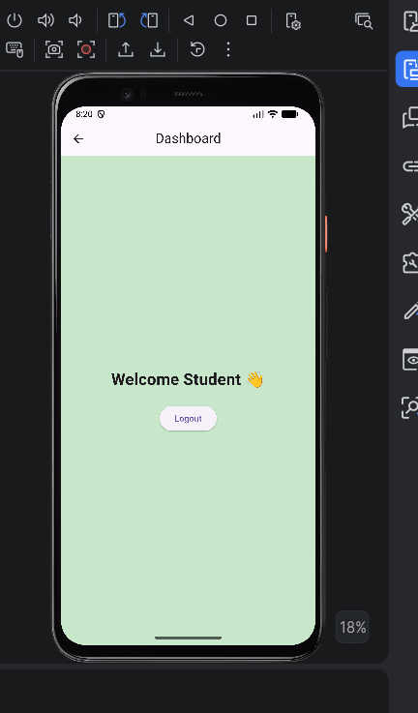
- Dashboard Screen

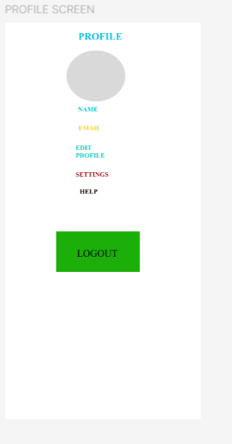
- Profile Screen

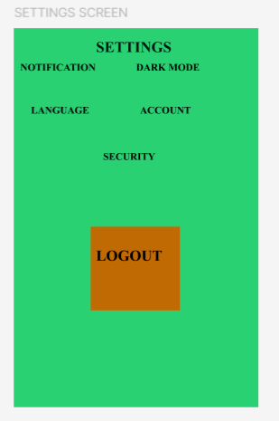
- Settings Screen

- Student API Screen
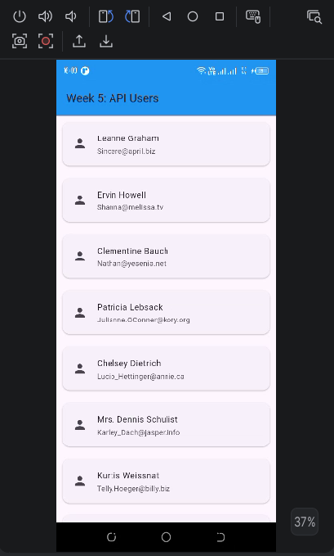

Appendix B: Source Code
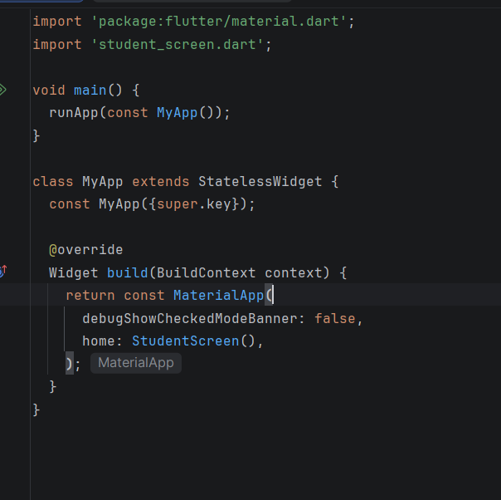
- main.dart

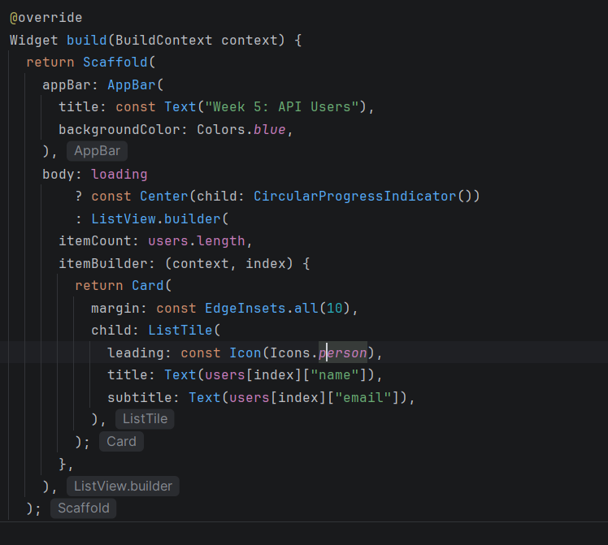
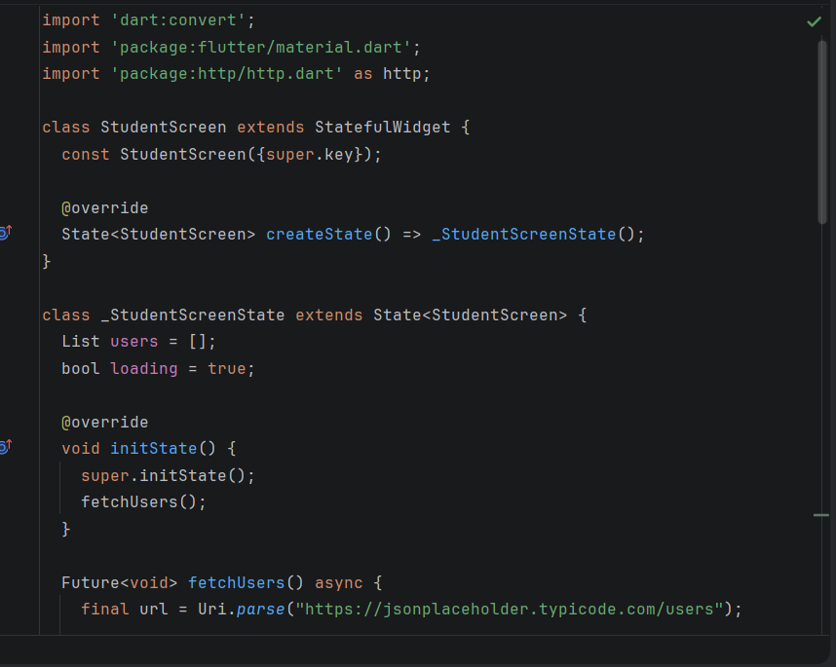
- student_screen.dart

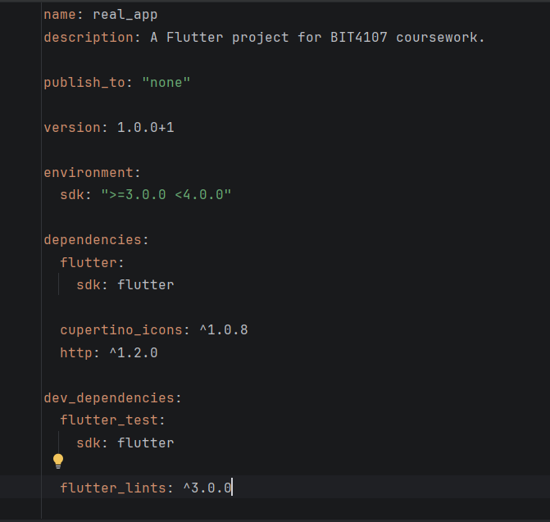
- pubspec.yaml

Appendix C: GitHub Repository Link

